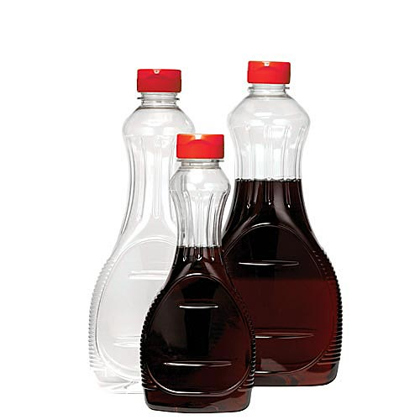
PEER EDITITING
SYRUP LOGO: BRAND MASCOT PROJECT

Logo Designer: Sydney Garcia
Peer Editor: Logan Shaker
Switch computers with another student. Complete this sheet on his/her computer. SAVE. Upload FILE to Weebly after you make changes and upload your finished logo.
- What era do you think this logo represents?
-50s
- What design choices did the student make to represent their era? (hair style, colors, fonts, prints or patterns, etc.)
-The checker board pattern and diner design
- Are ALL logo project requirements fulfilled?
-Yes all the requirements are met.
- Do you think the logo looks finished? Why or why not.
-Yes, the design fits well, the colors match the theme, and the text is edited correctly.
- What do you like about the logo?
-I like the pancakes that were put in and the drop shadows on the music notes.
- What tools do you see that the student used?
-Type on a path, text blending options, and crop tool
- What suggestions do you have for this student? Is there anything you would add or change to make the logo look more professional? What are some other tools or pieces that can be added to make the most of Photoshop tools?
-I would make the text easier to read because parts of the red blend into the background, and to make the background even cut off the half of the squares all the way to the right.

